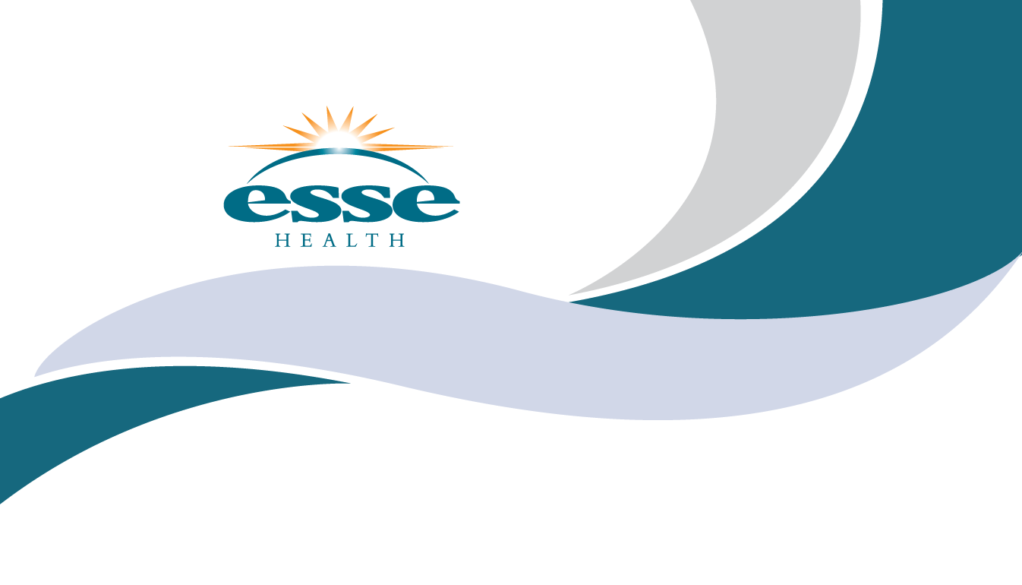
It’s important to start talking to your family about your end-of-life-wishes and everyone should have an Advanced Directive. Being prepared can help ease the burden and fear for you and your family.
Please come to an informational session presented by the Gateway End-of-Life Coalition to:
- Learn about The Conversation Project and how to start talking about your wishes
- Understand the important legal documents needed to state your wishes
- If you are ready, complete an Advance Directive with the attorney and notary present
- Meet some of the Esse Health physicians
Northwest Healthcare Community Room
Thursday, August 23rd, at 6 p.m.
1225 Graham Rd, Florissant, MO 63031
Please register for this event at http://bit.ly/theconversationproject
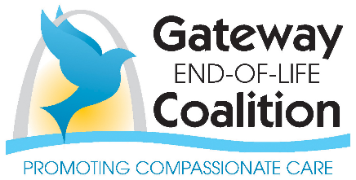
To find out more about Gateway End-of-Life Coalition or for other sponsored events visit www.gatewayeol.com

