Victory Lakes Pastoral Care
Grief, Loss and life Transitions Ministry
Presents:
Our Constantly Changing Lives:
The Healthy Role of Grief

With Educator:
Amy Florian, MA, FT
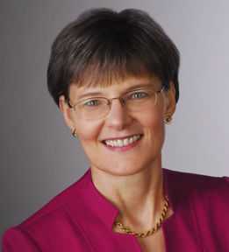
Tuesday, June 6, 2017, 6:00-8:00pm
Independent Living Great Room
1075 E. Victory Drive
Lindenhurst, IL 60046
RSVP (847)356-4523 or
darmenta@franciscancommunities.com
All are welcome. Refreshments Served.
Amy holds a Master’s Degree and is a Fellow in Thanatology (the highest level of certification in the field of grief studies). She taught a graduate class at Loyola University of Chicago for nine years, has worked with over 2,000 grieving people, and consults with firms, corporations, and individuals around the globe.
We are grateful for the sponsorship of this program by:

