Announcing a Joint Meeting of the
St. Louis Palliative Care Network and the
American Society for Pain Management Nursing
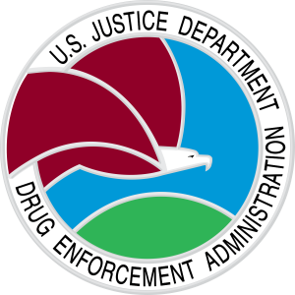
Speaker: Mr. Scott Collier
Diversion Program Manager of the St. Louis Division of the
U.S. Drug Enforcement Administration

"Opioids - From RX to Heroin"
DEA’s red flags for illicit prescribing & trafficking of prescription opioids
And appropriate prescribing for those who need them

Wednesday July 12, 2017
5:30 Networking
6:00 Dinner
6:30 Program

Garden Villas
13590 South Outer 40 Rd
Town & Country, MO 63017

RSVP by July 3, 2017 to Michelle.Schultz2@Mercy.net or Register at https://aspmnstlouisregional.nursingnetwork.com/

Directions: From Hwy 40 take Hwy 141 south (exit 22) and follow the signs to South Outer 40 Road going east. Stay in right lane on the Outer Rd, go slowly up first small hill and turn right immediately after the entrance to Cordell and Cordell – Kellwood. You may park in the Cordell parking lot. If you miss it, turn right into Delmar Gardens West and park on their lot and walk up to the Garden Villas building.

Sponsored by
: 