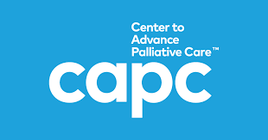
St. Louis Palliative Care Network presents
CAPC Roundup 2018
Highlights from
CAPC National Seminar 2018
Orlando, Florida

Thursday January 17, 2019
5:30 p.m. Dinner and Networking
6:00-8:00 p.m. Roundtable Presentation

Mercy Hospital Von Gontard Conference Center
South/Caroll Conference Room
621 S. New Ballas Rd, Creve Coeur, MO 63141

Register Here
Registration deadline is Jan. 10, 2019
Questions? Contact Michelle.Schultz2@Mercy.net

Mercy Hospital St. Louis is accredited by the Missouri State Medical Association (MSMA) to provide continuing medical education for physicians. Mercy Hospital St. Louis designates this live activity for a maximum of 2 AMA PRA Category I Credit(s)™. Physicians should claim only the credit commensurate with the extent of their participation in the activity.

